[TITLE - Font – Times New Roman, Font Size 14] Landfill Leachate Treatment by an Anaerobic Process Enhanced with Recyclable Uniform Beads (RUB) of Seaweed Species of Gracilaria

[AUTHORS NAME - Font – Times New Roman, Font Size 11] Sivathass Bannir Selvamª, Shreeshivadasan Chelliapanª*, Mohd. Fadhil Md. Din^{b}, Hesam Kamyabª, Samira Kamaruddin Albatiª, Norazli Othmanª, Ali Yuzir^{c}

ªUTM Razak School of Engineering and Advanced Technology, Universiti Teknologi Malaysia, Jalan Sultan Yahya Petra, 54100, Kuala Lumpur, Malaysia

^{b}Centre for Environmental Sustainability and Water Security (IPASA), Research Institute for Sustainable Environment, Block C07, Level 2, Universiti Teknologi Malaysia, 81310, Johor Bahru, Johor, Malaysia

^{c}Department of Environmental Engineering and Green Technology, Malaysia-Japan International Institute of Technology (MJIIT), Universiti Teknologi Malaysia, Jalan Sultan Yahya Petra, 54100, Kuala Lumpur, Malaysia

*Corresponding Author: Shreeshivadasan Chelliapan
Department of Engineering, UTM Razak School of Engineering and Advanced
Technology, Universiti Teknologi Malaysia, Jalan Semarak, 54100, Kuala Lumpur,
Malaysia.
Email: shreeshivadasan.kl@utm.my; Tel: +603-21805414; Fax: +603-21805188

[ABSTRACT & KEYWORDS - Font – Times New Roman, Font Size 11]
Abstract
Landfill leachate containing heavy metals was subjected to anaerobic treatment by using an up-flow anaerobic sludge blanket (UASB) reactor combined with recyclable uniform beads (RUB) of seaweed species of Gracilaria. During the treatment of leachate without the RUB, the organic loading rate (OLR) was increased in stages from 0.125 - 0.833 kgCOD m⁻³d⁻¹ and further increased to 2.50 kgCODm⁻³d⁻¹ by reducing the hydraulic retention time (HRT) from 4 - 1 d. Results showed that the COD removal efficiency declined from 65.70% to 9.33% when the OLR was increased from 0.125 - 2.50 kgCODm⁻³d⁻¹. The removal of Cadmium (Cd), Nickle (Ni) and Iron (Fe) was almost constant, regardless of the OLR [around Cd (36%), Ni (32%) and Fe (29%)]. However, when the leachate was treated with UASB + RUB, a complete removal (100%) of Cd, Ni, and Fe was witnessed. Fourier Transform Infrared Spectrometer (FTIR) spectra of RUB pre and post leachate treatment indicated clearly that RUB was the major component that worked to remove the heavy metals. The functional groups that were responsible for the removal of heavy metals were hydroxide (O-H), amine (N-H), carboxylic (C=O), amide (N=O), sulfinyl (S=O) and sulphides (C=S).

Keywords: recyclable uniform beads (RUB), seaweed extract, up-flow anaerobic sludge blanket (UASB), landfill leachate, heavy metals, Gracilaria sp.

[MANUSCRIPT - Font – Times New Roman, Font Size 12]
[REFERENCE – Please use Number format]
- Introduction
Landfilling is the primary method of waste disposal in developed and developing countries [1]. Although this method has numerous benefits, one of its disadvantages is leachate production, which must be properly managed. Without proper treatment, landfill leachate will greatly increase water pollution as it can penetrate through soil and subsoil. Leachate contains water, organic and inorganic chemical substances as well as recalcitrant chemicals, for instance, excessive phosphate, nitrates and metal salts, including heavy metals [2]. Heavy metals, such as cadmium (Cd), chromium (Cr), copper (Cu), lead (Pb), nickel (Ni) zinc (Zn) and iron (Fe) are common heavy metals found in leachate [3]. The main sources contributing to the presence of heavy metals are typical home appliances, such as fluorescent tubes, garden pesticides, batteries, waste oil, paint and electronic waste [4]. Heavy metals may be potentially phytotoxic and pose a threat to animals and humans health via the food chain.
Heavy metals and other toxic compounds are removed during the final treatment process in the landfill. Current leachate treatment options include recycling, on-site treatment, biological treatment, chemical oxidation and discharge to a municipal water treatment facility, or a combination of the above. However, biological treatment is still widely used in landfill leachate treatment. In this regard, the UASB is intensively researched for landfill leachate treatment. One of the problems during treatment by using UASB is the inhibition of the biological treatment of toxic compounds found in leachate such as heavy metals. Accordingly, the present study investigates the landfill leachate treatment by combining the UASB with naturally found seaweed for process optimisation.
Seaweeds, widely known as macroalgae, are predecessors of all terrestrial plants. The macroalgae can be divided into three major categories: brown macroalgae, green macroalgae and red macroalgae. Seaweeds lack structures such as roots and leaves which are typical of terrestrial plants. Thus, seaweed does not utilise nutrients in the same way as terrestrial plants do. Seaweeds have a root-like structure called holdfast, which serves to attach the seaweed to substrates [5]. The rest of the seaweed structure is called thallus. The thallus contains pigments for photosynthesis. Since seaweeds lack roots for nutrient uptake, the thallus or thalli are used to obtain nutrients from the surrounding waters by diffusion and active transport [6]. This particular feature of seaweed allows it to absorb nutrients in the form of salts and metals, which are available in seawater. Abdel-Raouf et al. [7] reported that seaweed, in its natural and extracted form, is able to absorb heavy metals from synthetic wastewater and metallurgy wastewater. Naturally found seaweed provides an attractive and cost-effective solution for heavy metals removal from landfill leachate. The red seaweed (Gracilaria sp.) mainly constitutes polysaccharide agarose and carrageenan; thus, it has a high potential for heavy metals accumulation. Metal ion uptake by biomass occurs through interaction with the cell walls. This is due to the presence of various functional groups, such as carboxyl, amino, sulphate and hydroxyl groups, which act as binding agents, and involve ionic interactions and complex formations between metal cations and ligands on the surface of the seaweeds.
This study aims to optimise the anaerobic treatment by using a UASB reactor and utilising seaweed extract as an adsorbent of heavy metals for leachate treatment. The research specific objectives for accomplishing the aims are as follows; to evaluate the efficiency of UASB reactor in the landfill leachate treatment at various organic loading rates and to assess the performance of the UASB reactor with the addition of seaweed extract (RUB).

- Materials and methods
2.1 Up-flow anaerobic sludge bed (UASB) reactor
The UASB used in this experimental study was 18 cm in internal diameter and 110 cm in height, with an active volume of 20 L. The reactor had a 3-phase separator baffle (pore diameter of 2 mm) placed 2 cm below the effluent ports to prevent floating granules from being washed out with the effluent. Sampling ports were placed at 8 cm intervals (lowest being 21 cm from the base) that allowed biological solid and liquid samples to be withdrawn from the sludge bed. The influent wastewater entered through a 2.7 cm down comer tube at the head plate that extended to within 105 cm of the reactor base and allowed the feed to flow upward through the sludge bed. A temperature controller and heater were installed to maintain the reactor temperature at 37 °C.

2.2 Landfill leachate
The landfill leachate was obtained from an ageing leachate treatment pond at Jinjang transfer station, in Selayang, Selangor, Malaysia and had the following characteristics: pH=8.0, COD=2500 mgL⁻¹, As=9.40 mgL⁻¹, Fe=12.8 mgL⁻¹, Ni=0.50 mgL⁻¹ and Cd=0.43 mgL⁻¹. The leachate used in this study was collected at once and stored, then was used throughout the study. Thus, the characteristics were constant.

2.3 UASB operations
The reactor was seeded with anaerobically digested sewage sludge (Bunus Sewage Treatment Plant, Kuala Lumpur). Twelve litre of sieved sludge (by using a 2.0 mm mesh) was filled into the UASB, and the remaining volume being filled with tap water. This amount of sludge substantially contributed to the solid requirement in the reactor system after settling. The sieved sludge contained total solids of 30,100 mgL⁻¹ and total volatile solids of 9,525 mgL⁻¹. After seeding, the head plates were attached, and the headspace above each compartment was flushed with nitrogen gas to displace residual air in the system before introducing the feed. The reactor was allowed to stabilise at 37°C for 7 d without further modification. A total of 7 L of sieved sludge was added to the reactor, and the reactor was subsequently filled with tap water up to 20 L. The reactor was then flushed with excess nitrogen gas to remove the remaining air within the reactor headspace and was allowed to stabilise at 37 °C temperature for 24 hours. The start-up of the reactor was carried out by using dilute leachate with a very low COD concentration. Once the reactor attained a steady state condition (>80% COD removal), the feed (leachate) concentration was gradually increased by reducing the amount of water added. The OLR was increased stepwise from 0.125 - 0.833 kg COD m⁻³ d⁻¹ and increased further to 2.5 kg COD m⁻³ d⁻¹ by reducing the HRT from 4 d to 1 d. Finally, the OLR was again reduced to 0.375 kg COD m⁻³ d⁻¹ (HRT 4 d) to determine the ability of the reactor to recover the treatment efficiency (Table 1). The OLR was returned to the low level to observe the reactor capability to return to stable condition. The optimum macronutrient to COD ratio was maintained at COD: N: P =250: 7: 1 by adding N100 (Bio-Systems Corporation Asia Pacific Sdn Bhd) macronutrient supplement. The choice of this nutrient was based on inadequate nutrients in the landfill leachate. There were no excessive nutrients added to the feed as N100 was first diluted 10 times of its original concentration. In addition, the reactor was operated by using these nutrients, previously used for the treatment of palm oil mill effluent and showed stable reactor operations. Average values of the measured parameters quoted for each OLR were based on three data points taken when the reactor achieved a steady state.

Table 1: Summary of reactor operating conditions during the investigation of OLR on leachate treatment process
Feed COD (mgL⁻¹ ) | OLR (kgCODm⁻³d⁻¹) | HRT (d) | Duration (d)
500 | 0.125 | 4.0 | 1–20
1500 | 0.375 | 4.0 | 20–40
2500 | 0.625 | 4.0 | 40–60
2500 | 0.833 | 3.0 | 60–75
2500 | 1.25 | 2.0 | 75–85
2500 | 2.50 | 1.0 | 85–90
1500 | 0.375 | 4.0 | 90–105

2.4 Sampling and analysis
Sample analysis, such as COD, pH and volatile acids (VA), was conducted according to standard methods [8]. The total biogas volume was determined by using an optical gas bubble counter. The biogas composition was determined by using a portable gas analyser (GA2000, Geotechnical Instruments). Heavy metal analysis of the leachate was conducted by using an atomic absorption spectrometry (AAS, AA-7700, Shimadzu Corp.).

  - RUB
The dried local seaweed species of Gracilaria sp. was made into gels of different concentrations and tested for several properties, such as gel strength, gelling and melting temperature and alginate yield before proceeding to bead development. The following sections describe the gel properties analysis.

    - Agar yield
Agar yield was examined according to the method described by the Food and Agriculture Organization (FAO) [9]. A fresh sample of seaweeds was weighed (wet weight) and 100 g of the fresh sample was dried in various conditions, such as air drying, solar drying and oven drying at 60°C and 100°C temperatures. Then the dry weight of each sample was determined. A 10 g sample from each drying condition was obtained and boiled in 500 ml water for 1 hour. The extract produced from the boiling was then filtered through a glass microfibre filter and allowed to cool. The filtrate was frozen and oven dried for 24 hours at 60°C. The final weight of the dried sample was measured to determine the agar yield under various drying conditions.

    - Gel strength
Gel strength was measured via a penetration test according to Marinho-Soriano and Bourret [10] and Kumar and Fotedar [11]. The gel strength was determined by a plunger with a 1 cm² surface area and by penetrating the gel at a speed of 1 mms⁻¹ to a depth of 5 mm.

2.5.3 Gelling temperature and melting temperature
These experiments were performed according to methods described by Freile-Pelegrin and Murano [12] and Kumar and Fotedar [11]. A spherical glass bead was placed onto the gel, which was about to be cooled during the cooling phase of the agar yield study. Then, the gel was allowed to cool down together with the glass bead in it and the gel matrix, together with the glass bead entrapped in it, was reheated. Thus, the melting point of the gel is the temperature at which the glass bead entrapped in the gel matrix completely sinks into the gel and reaches the bottom of the container.

2.5.4 Alginate yield
Alginates are polysaccharides found in seaweeds that have carboxyl group in their molecules for metal chelation and absorption of chemical molecules. This study is based on the methods illustrated by the FAO [9]. A sample of 10 g of fresh seaweeds was soaked in sodium bicarbonate solution. The alginic acid salts will precipitate in the alkaline sodium bicarbonate solution. This alkaline solution was then filtered by using a microfibre glass filter paper. Then the filter paper was washed with hydrochloric acid. The precipitated insoluble alginic acid was collected on the filter paper. By calculating the difference between the initial weight of the filter paper and the final weight of the filter paper, the alginate yield can be determined.

2.5.5. Gel characterisation by fourier transform infrared spectrometer (FTIR)
A concentrated solution of the gel was prepared in a suitable solvent (CH₂Cl₂). A small amount (2 mg - 5 mg) of the gel was directly placed on the plates and one drop of solvent was added. The potassium bromide plates were thoroughly cleaned after this procedure to prevent contamination of future samples. The windows were wiped with a tissue and then washed several times with a solvent, then ethanol. The polishing kit in the lab was used to polish the window surface. The cleaned surface was clear and free from scratches. The infrared spectra of the gel were determined by using a Fourier Transform Infrared Spectrometer (FTIR) (Agilent Cary 600 Series FTIR). The gel was ground with Spectroscopic (IR) grade Potassium Bromide (KBr) powder and then pressed into 1 mm pellets for FTIR measurement in the wavenumber range of 600 cm⁻¹ and 4000 cm⁻¹ via 16 scans.

2.6 Development of RUB
After a methodical study of the properties of seaweeds, agar development of spherical beads can begin. The spherical shape provides a high surface area to volume ratio, which increases the efficiency of treating pollutants from leachate. Cold used oil spherification was used to develop the seaweed beads. Based on the results of gel test and jar test, the best seaweed species and optimum gel concentration were used to make beads. An optimum amount of dried seaweed was introduced into a 1 L beaker and 0.4 ml of water was added. The mixture was left to boil for 1 hour. After 1 hour, the hot extract was filtered and left to cool for 15 minutes. The cooled extract solution was immediately introduced into the cold used oil (refrigerated for 24 hours prior to the experiment) by using a syringe to produce spherical beads. Due to the low temperature and insolubility in oil, the boiled extract will gelify in spherical shapes at the bottom of the container.

2.7 Spherical Bead Filter
From the results of gel strength, gelling temperature and melting temperature, a spherical bead filter was designed. Based on the working temperature range, a suitable material to store the filter medium was plexiglass. This is due to the heat insulating properties of plexiglass. Another advantage of plexiglass is that it is transparent; thus, the operation of filter medium could be observed by the eye. The filter was cylindrical in shape, with a base of 5 cm diameter and 30 cm height. This filter design was optimal to support stacks of spherical beads on top of each other without crushing the beads. The bead had a diameter of 0.5 cm and it was loosely packed to allow feed flow without resistance and at the same time, the loosely packed beads would also ensure that there was no clogging in the filter medium.

3. Results and discussion

  - Treatment of leachate by UASB
Figure 1 (a) illustrates the average pH variations in the UASB when the OLR was gradually increased from 0.125 to 2.50 kgCODm⁻³d⁻¹. The pH levels were stable (pH 8.37– pH 7.53) in the UASB until the reactor OLR exceeded 0.625 kgCODm⁻³d⁻¹. At a reactor OLR of 0.833 kgCODm⁻³d⁻¹, the pH in the reactor dropped to pH 6.77 due to the rapid production of VFAs resulting from the increased acidogenic activity. A further increase in the OLR to 1.25 kgCODm⁻³d⁻¹ and 2.50 kg COD m⁻³d⁻¹ diminished the pH of the reactor to pH 6.10 and pH 5.48, respectively. However, when the reactor OLR was reduced back to 0.375 kgCODm⁻³d⁻¹, the pH in the reactor recovered to pH 8.37, indicating that the acidogenesis and methanogenesis had recovered to previous levels under low OLR conditions. From the pH data, it can be assumed that the metabolic processes differed between each OLR of the UASB system, causing each OLR to favour a unique population of microorganisms. As displayed in Figure 1 (a), the VFA concentration in the reactor was lower than 300 mgL⁻¹, considered acceptable for a UASB reactor system [13]. The VFA concentration was observed to be low when operated at an OLR in the range of 0.125 kgCOD m⁻³d⁻¹ - 1.25 kgCOD m⁻³d⁻¹. Increasing the OLR beyond 1.25 kgCOD m⁻³d⁻¹ resulted in higher VFA concentrations in the effluent. A drastic increase in VFA concentration was observed (255.7 mgL⁻¹) at OLR of 2.5 kgCODm⁻³d⁻¹. When the OLR was reduced to 0.375 kgCODm⁻³d⁻¹, the VFA concentration began to decline and stabilised to 157.3 mgL⁻¹. Reduced contact time between the substrate and biomass in UASB favoured the activity of acidogens, leading to decreased methanogen activity in the reactor [14]. Some of the variations in the VFA profiles may be influenced by the presence of inhibitory substances, such as heavy metals [15]. At an OLR of 0.125 kgCODm⁻³d⁻¹ (HRT 4 d), the average COD removal efficiency was 65.70% (Figure 1b). The increase of the OLR from 0.375 kgCODm⁻³d⁻¹ to 1.250 kgCODm⁻³d⁻¹ resulted in a decreasing COD removal efficiency until 9.33% was observed at an OLR of 2.50 kgCODm⁻³d⁻¹. It is unlikely that this was caused by limitations in the UASB reactor as this reactor was shown to achieve over 90% COD removal at high OLR (e.g., more than 20 kgCODm⁻³d⁻¹) [16]. However, matured landfill leachate containing a high proportion of recalcitrant and complex organic carbon content may limit the UASB performance at high OLR. Moreover, heavy metals concentrations in the feed (leachate) may also contribute to the poor performance of the reactor system [17]. Organic matters washed out from the reactor in the form COD may have contributed to the overall low removal of COD.
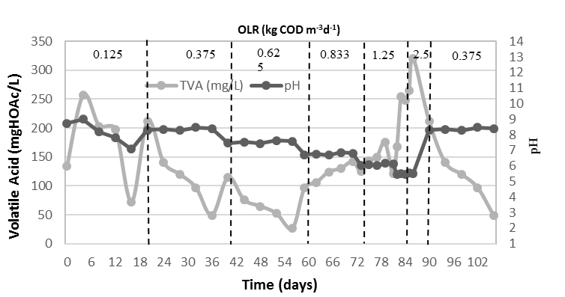
(a)
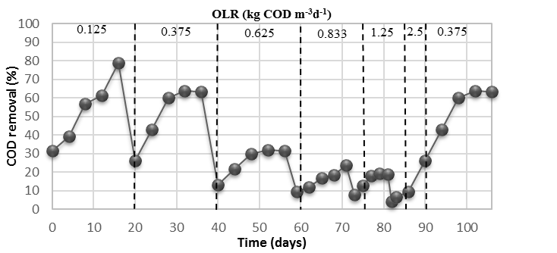
(b)
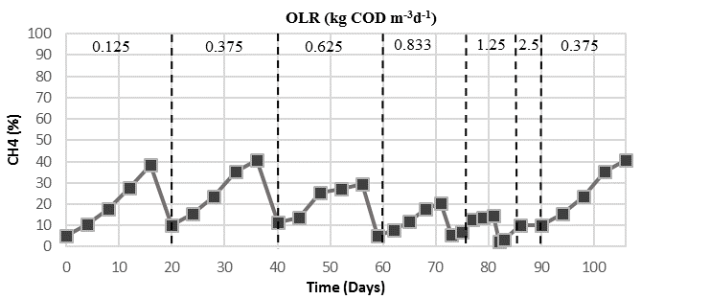
(c)
Figure 1: UASB performance profile for landfill leachate treatment, a) pH and VA, b) COD removal, and c) Methane composition

The average methane composition fluctuated from 38.50% to 9.53% (Figure 1c), likely due to the changes in the OLR, since the methanogenic bacteria are sensitive to the changes in feed OLR. As an indirect measure of biomass fluctuations in the reactor, the suspended solids (data not provided) in the reactor correlated well with the methane generation. The methane composition profile followed the COD removal efficiency, where the concentration was reduced concomitantly with COD removal. A similar trend was also observed for the VFA profile. Abbassi-Guendouz et al. [18] demonstrated that VFA decreased when methane composition decreased in an anaerobic treatment process. The methane profile has a close relationship with pH where a decrease in the pH affects the methane generation [19]. Overall, the methane percentage was low first of all due to the fact that matured leachate contains a less organic fraction. Besides that, the high pH value could also be the reason for lack of methanogenic activity.

3.1.1 Heavy metal removal
Table 2 shows the effect of OLR on the heavy metals removal. It can be seen that the removal of Cd, Ni and Fe were almost constant, regardless of the OLR [around Cd (36%), Ni (32%) and Fe (29%)]. The stable population of bacteria appears to tolerate the introduction of these metals into the reactor system when the OLR gradually increased from 0.125 to 2.5 kgCODm⁻³d⁻¹ and decreased back to 0.375 kgCODm⁻³d⁻¹. In contrast, the degree of removal at low OLR’s (e.g., 40% at 0.125 and 0.833 kgCODm⁻³d⁻¹, respectively), but at high OLR (e.g. 2.5 kgCODm⁻³d⁻¹), was dramatically decreased (3.83% and 7.81%, respectively). When the OLR was decreased back to 0.375 kgCODm⁻³d⁻¹, some removal was still evident (around 26%), signifying that the anaerobic microorganisms in the reactor were capable of recuperating from the shock load. The removal of heavy metals could have occurred by either bioaccumulation or accumulation in sludge [20]. Bioaccumulation was less likely to be possible, thus, the pollutants might have accumulated in the sludge.

Table 2. Effect of OLR on heavy metal removal
OLR  (kg CODm⁻³ d⁻¹) | Heavy Metal Removal (%)
 | As | Cd | Ni | Fe
0.125 | 40.00 | 36.36 | 32.00 | 29.69
0.375 | 40.00 | 36.92 | 33.33 | 29.69
0.625 | 40.00 | 37.04 | 32.80 | 29.69
0.833 | 40.00 | 36.36 | 32.93 | 29.69
1.25 | 18.72 | 36.28 | 32.80 | 29.70
2.5 | 3.83 | 36.28 | 32.80 | 29.70
0.375 | 26.04 | 36.92 | 33.33 | 29.69

  - Leachate treatment by UASB and RUB
After successfully creating RUB and placing it into the adsorbent holder, a pre-treatment step to enhance the treatment of leachate and then conducting UASB treatment was performed. In this phase, the reactor was operated at a fixed HRT (4 d) and OLR (0.375 kgCODm-3d-1) and performance were evaluated and compared before and after the combination of RUB with the UASB. Figure 2(a) illustrates the pH variations when the leachate was treated by UASB and UASB + RUB. The pH levels were generally stable (7.98 - 7.01) in the treatment of leachate by UASB and in the treatment of leachate by UASB + RUB (7.51 - 6.64). pH is an important parameter in anaerobic treatment performance and many studies have shown the optimum pH for the anaerobic digestion is in the alkaline region [21]. The anaerobic process could be advantageous to methanogenic bacteria when the pH ranges from 6.5 - 7.5 [22]. From the pH profile, it can be assumed that the UASB + RUB treatment of leachate takes place at a more suitable pH for methanogenic bacteria activity as compared to UASB treatment of leachate.

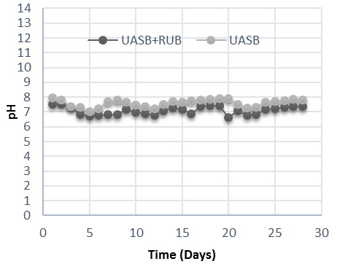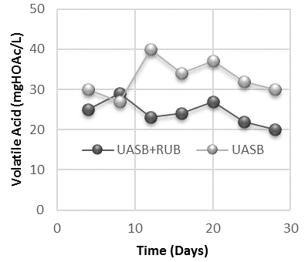
- (b)
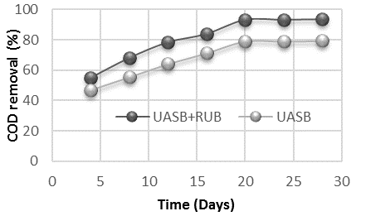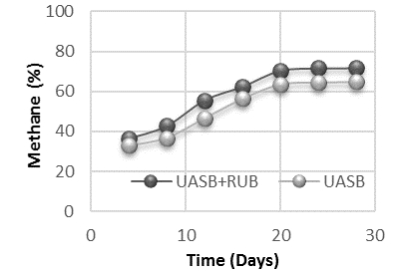
(c) (d)
Figure 2: UASB performance profile before and after the treatment with RUB, a) pH, b) volatile acid, c) COD removal and d) methane composition

Figure 2 (b) illustrates that VA concentrations were better in UASB + RUB than in UASB treatment. This was evident because as the VA values registered were lower after UASB + RUB treatment of leachate than UASB treatment. The VA concentration is an indicator of feed utilisation by anaerobic microorganisms. When there is a build-up of VA in the anaerobic system, it is probably an indication of the anaerobic microorganism’s failure to utilise the VA as feed. Conversely, the results of UASB + RUB and UASB treatment leachate revealed that there was no obstruction to VA utilisation by anaerobic microorganisms as all the VA registered readings within the range that indicated a healthy anaerobic system [23]. However, the addition of RUB enhanced the leachate treatment by almost 50% as compared to the average value of VA. Results of COD removal by UASB + RUB and UASB treatment of leachate are illustrated in Figure 2 (c). Both treatment systems attained a constant COD removal after Day 20, however, the values attained had set them apart. The UASB + RUB treatment of leachate has an edge over UASB treatment of leachate as it could achieve removal up to 93%. The remainder of untreated COD in the effluent probably belongs to inorganic constituents or originated from bacterial waste generated during the UASB + RUB treatment process itself. The addition of RUB to the UASB system improved the COD removal by 15%. The average methane composition at steady state was 71.3% and 64.17% (Figure 2 (d)) for UASB + RUB and UASB treatment of leachate, respectively. The methane composition profile followed the COD removal efficiency pattern, whereby, it steadily increased up to 20 days and then stabilised for both treatment systems. The combination of RUB with UASB increased the methane composition by 7.13% on average at steady state.

    - Heavy metal removal
Table 3 shows the heavy metals removal in leachate by UASB + RUB and UASB. This indicated that the anaerobic microorganisms utilised the pollutants or it was absorbed by the RUB. This explains the trend observed in heavy metals speciation in the current study (data not provided), whereby UASB + RUB always displayed a higher efficiency in heavy metals removal from leachate as compared to UASB. UASB treatment of leachate registered poor treatment effectiveness for heavy metals, as the removal for As, Cd, Ni and Fe was 40.00, 36.36, 32.00 and 29.69%, respectively (Table 3). However, when the leachate was treated with UASB + RUB the removal efficiency of As, Cd, Ni and Fe drastically increased to 95.4%, 100%, 100% and 100%, respectively. Gracilaria sp. based adsorbents are capable of adsorbing 0.15 to 0.76 mmolg⁻¹ of Cd and 0.2 mmolg⁻¹ of Ni, which is equivalent to 0.058 to 0.2939 mgL⁻¹ of Cd and 0.0773 mgL⁻¹ of Ni [6]. The current study reports similar adsorption capacities as compared to values mentioned by the researchers. However, no relevant literature regarding the adsorption of other metals was found.

Table 3: Heavy metal removal profile by UASB + RUB and UASB
Treatment type | Heavy Metal Removal (%)
 | As | Cd | Ni | Fe
UASB | 40.00 | 36.36 | 32.00 | 29.69
UASB + RUB | 95.4 | 100 | 100 | 100

3.2.2 FTIR spectra of RUB pre and post leachate treatment
This section discusses the results obtained from FTIR spectroscopy analysis of RUB before and after they were used in leachate treatment. Figure 3 a) illustrates the spectral result of RUB prior to the leachate treatment at the beginning. Meanwhile, Figure 3 b) illustrates the result of spectral analysis of RUB extracted from the adsorbent holder after the leachate treatment at the end. Figure 3 c) illustrates the overlay of a) and b) to facilitate observation of changes that occurred (if any) in the bands or functional groups present in the RUB. Although Figure 3a) and Figure 3b) appear similar, which is typical of spectral samples of the same substance, a distinctive difference is visible in the overlaid image. The increase of absorbance in the 3500 - 3000 cm⁻¹, 1700 -1500 cm⁻¹, 1200 - 1000 cm⁻¹ and 661 cm⁻¹ indicates clearly that RUB is the major component that has worked to remove the heavy metals.

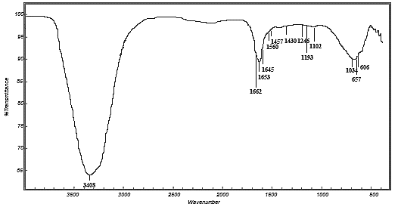
a)

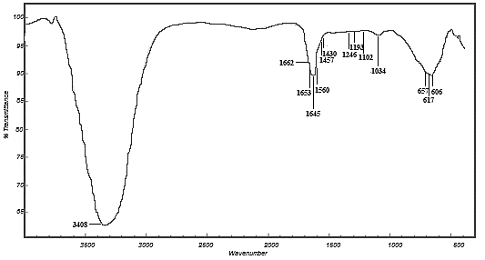
b)

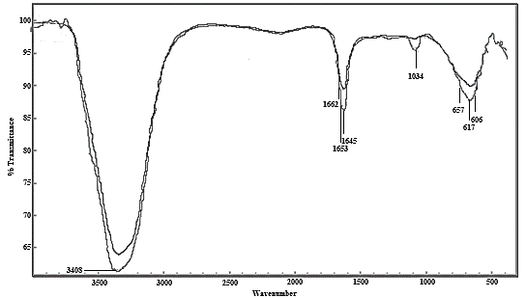
c)
Figure 3: FTIR spectroscopy of RUB pre and post leachate treatment, a) RUB before treatment, b) RUB after treatment and c) Overlay of a) and b)

From Table 4, it is evident that functional groups or compounds that are present in the RUB are the major adsorbing agents. A study by Yanagisawa et al. [24] also confirms the presence all the aforementioned functional groups and compounds present in the Gracilaria sp. sample. RUB made of Gracilaria sp. proves to be a good adsorbent for the pollutants present in matured leachate sample. This is evident from the results (Figure 3 and Table 4) of FTIR study of the bead before and after adsorption study. The results revealed that there were 4 major chemical components responsible for pollutants removal from the matured leachate. The first region was found to be the 3408 cm⁻¹, where it indicated the N-H or amine, O-H or hydroxide bond which can be found in polysaccharides or water molecules. This region was found to possess prominent absorbance as compared to other regions in the FTIR result, which shows that it is the most abundant functional group present in the RUB. Consequently, the order of functional group abundance was followed by C=O or carboxylic, N=O or amide, S=O or sulfinyl, and C=S or sulfides. The comparison was made respective to the absorbance area acquired by each functional group. The results revealed that pollutants (heavy metals) could be adsorbed by more than one functional group.

Table 4: Characterisation of RUB using FTIR
Gracilaria sp. | Functional Groups | Compound
Abs. Fre (cm⁻¹)
3408 | N-H Stretching  O-H Stretching | Amino acids Polysaccharides
1662, 1653,  1645 | C=O Stretching,  N=O asymmetric  Stretching (Nitrate) | Ester, Pectin
1560 | C=C Stretching | Lignin
1457, 1430 | C- O Stretching  O-H bending | Cutin
1246 | C-C-O, S=O Stretching | Lignin
1193 | C-O Stretching (phenols)  C-F Stretching | Cellulose
1102 | C-F Stretching  Si-O | Cellulose,  Carbohydrates
1034 | S=O Stretching  (sulfonides) | Starch and  Polysaccharides
657, 617  606 | C-S Stretching  C=S Stretching (sulfides) | Sulfates

Despite the multifaceted adsorbent nature of the functional groups in the RUB, the common factor which acts as the driving force of the adsorption process is the lone pair of electrons present in the functional group. Lone-pair electrons signify the pair of valence electrons which are not shared with an adjacent atom. According to Lewis structure of functional group and quantity of lone-pair of electrons [25], functional group with the lone-pair electrons is sulfynil (S=O) which has 4 lone-pair of electrons, followed by hydroxides (O-H), and amides (N=O) which has 3 lone-pair of electrons, carboxylic (C=O) functional group has 2 lone-pair of electrons and amine (N-H) and sulfide (CS) have 1 lone pair of electrons each. Heavy absorbance at the O-H and N-H regions of the FTIR spectra indicates the dominance of this functional is in abundance. Apart from the sulfinyl presence and sulfide is also heavy in terms of absorbance in FTIR spectra. That is evident when there is a sharp increase in absorbance of RUB after treatment spectra (Figure 3). In Figure 3 c) it was also clear that the C=O and N=O also have a sharp increase in absorbance in RUB after treatment spectra. From this result, we could only conclude that O-H, N-H, C=O, N=O, S=O and CS are responsible for the removal of pollutants in matured leachate. Further study is required to determine which functional group has the most significant role in the removal of these pollutants from the matured leachate.

4. Conclusions
This research was initiated with the main aim of optimising the anaerobic treatment by using a UASB reactor for leachate treatment by utilising seaweed extract as an adsorbent of heavy metals. From the experimental results, there appears to be considerable potential for the UASB combined with the RUB system to be implemented on-site for treatment of matured landfill leachate. The treatment efficiency of the reactor was affected at an OLR of 2.50 kgCODm⁻³d⁻¹, probably due to the recalcitrant nature of the wastewater containing high levels of heavy metals at elevated OLR. At high OLR, the concentration of heavy metals may have increased many folds, which may have inhibited the methanogens. The UASB + RUB treatment of leachate has the edge over UASB treatment of leachate as it could achieve removal up to 93%. UASB + RUB always has a higher efficiency in heavy metals removal from leachate as compared to UASB. The FTIR study of RUB after treatment revealed that there was an increase of absorbance and clearly indicated that RUB was the major component that has worked to remove the heavy metals.

Acknowledgements
The authors would like to thank Worldwide Landfills Sdn Bhd, Jeram, Selangor, Malaysia for supplying the landfill leachate. The authors also would like to thank Universiti Teknologi Malaysia and UTM Razak School of Engineering and Advanced Technology for funding this research under the High Impact Grant Razak School; Vote number R. K130000.7740.4J311.

References [REFERENCE – Please use Number format]
[1] H.A. Aziz, A. Mojiri, Municipal Landfill Leachate Treatment Techniques: An Overview, In book: Wastewater Engineering: Advanced Wastewater Treatment Systems Edition: First Chapter: Municipal Landfill Leachate Treatment Techniques: An Overview, IJSR Publications, Penang, Malaysia, 2014.
[2] S. Renou, J.G. Givaudan, S. Poulain, F. Dirassouyan, P. Moulin, Landfill leachate treatment: review and opportunity, J. Hazard. Mater., 150 (2008), 468-493.

[3] Y. Peng, Perspectives on technology for landfill leachate treatment. Arab. J. Chem., 10 (2017), S2567-S2574.
[4] S. Mohan, R. Gandhimathi, Removal of heavy metal ions from municipal solid waste leachate using coal fly ash as an adsorbent, J. Hazard. Mater., 169 (2009), 351-359.
[5] J.K. Kim, G.P. Kraemer, C. Yarish, Field scale evaluation of seaweed aquaculture as a nutrient bioextraction strategy in Long Island Sound and the Bronx River Estuary, Aquaculture, 433 (2004), 148-156.
[6] J. He, J.P. Chen, A comprehensive review on biosorption of heavy metals by algal biomass: materials, performances, chemistry, and modeling simulation tools, Bioresour. Technol., 160 (2014), 67-78.
[7] N. Abdel-Raouf, A.A. Al-Homaidan, I.B.M. Ibraheem, Microalgae and wastewater treatment, Saudi J. Biol. Sci., 19 (2012), 257-275.
[8] APHA, Standard Methods for the Examination of Water and Wastewater. American Public Health Association, Washington, 2005.
[9] FAO, The State of World Fisheries and Aquaculture, Food and Agriculture Organization, Viale Delle Terme Di Caracalla, Rome, 2012.
[10] E. Marinho-Soriano, E. Bourret, Polysaccharides from the red seaweed Gracilaria dura (Gracilariales, Rhodophyta), Bioresour. Technol., 96 (2005), 379-382.
[11] V. Kumar, R. Fotedar, Agar extraction process for Gracilaria cliftonii, Carbohyd. Polym., 78 (2009), 813-819.
[12] Y. Freile-Pelegrı́n, E. Murano, Agars from three species of Gracilaria (Rhodophyta) from Yucatán Peninsula, Bioresour. Technol., 96 (2005), 295- 302.
[13] L.S. Cadavid-Rodríguez, N.J. Horan, Production of volatile fatty acids from wastewater screenings using a leach-bed reactor, Water Res., 60 (2014), 242- 249.
[14] S. Chelliapan, T. Wilby, P.J. Sallis, Performance of an up-flow anaerobic stage reactor (UASR) in the treatment of pharmaceutical wastewater containing macrolide antibiotics, Water Res., 40 (2006), 507-516.
[15] J. Ye, Y. Mu, X. Cheng, D. Sun, Treatment of fresh leachate with high- strength organics and calcium from municipal solid waste incineration plant using UASB reactor, Bioresour. Technol., 102 (2011), 5498-5503.
[16] R. Mahmoudkhani, A.H. Hassani, A. Torabian, S.M. Borghei, Study on high- strength anaerobic landfill leachate treatability by membrane bioreactor coupled with reverse osmosis, Int. J. Environ. Res., 6 (2012), 129-138.
[17] T. Abbasi, S.M. Tauseef, S.A. Abbasi, Anaerobic digestion for global warming control and energy generation - An overview, Renew. Sust. Energ. Rev., 16 (2012), 3228-3242.
[18] A. Abbassi-Guendouz, D. Brockmann, E. Trably, E. Dumas, J.P. Delgenès, J.P. Steyer, R. Escudié, Total solids content drives high solid anaerobic digestion via mass transfer limitation, Bioresour. Technol., 111 (2012), 55-61.
[19] S.Y. Xu, H.P. Lam, O.P. Karthikeyan, J.W.C. Wong, Optimization of food waste hydrolysis in leach bed coupled with methanogenic reactor: Effect of pH and bulking agent, Bioresour. Technol., 102 (2011), 3702-3708.
[20] D. de la Varga, M.A. Díaz, I. Ruiz, M. Soto, Heavy metal removal in an UASB-CW system treating municipal wastewater, Chemosphere, 93 (2013), 1317-1323.
[21] M. Kawai, M. Kishi, M.R. Hamersley, N. Nagao, J. Hermana, T. Toda, Biodegradability and methane productivity during anaerobic co-digestion of
refractory leachate, Int. Biodeter. Biodegr., 72 (2012), 46-51.
[22] T. Lu, B. George, H. Zhao, W. Liu, A case study of coupling up-flow anaerobic sludge blanket (UASB) and ANITATM MOX process to treat high- strength landfill leachate, Water Sci. Technol., 73 (2016), 662-8.
[23] R.A. Hamza, O.T. Iorhemen, J.H. Tay, Advances in biological systems for the treatment of high-strength wastewater, J. Water Process Eng., 10 (2016), 128-142.
[24] M. Yanagisawa, S. Kawai, K. Murata, Strategies for the production of high concentrations of bioethanol from seaweeds, Bioengineered, 4 (2013), 224-235.
[25] S.F. Matar, J. Galy, Lone electron pair (E) role on the crystal structures and the mechanism of high ionic conductivity of PbSnF4E2. Stereochemical and ab initio investigations, Solid State Sci., 52 (2016), 29-36.

